Rapid Applications Group, LLC.
  - ROTG Office Manual

Rapid ERP Systems

Author: Andrew Bullis
Edit Version: 1.0
Version Date: 02/24/2017

4393 Pierson St p. 303-500-3050 Support@rapidappsinc.com
Wheat Ridge CO 80033 www.rapidappsinc.com

Chapters
Chapter 1: Send Job To Operators Tablet
Chapter 2: Enable Status Updating For The Operator
Chapter 3: Accepting Job Ticket On Invoice
Chapter 4: Printing Filled/Signed Job Ticket
Chapter 5: Viewing Jobsite Images
Chapter 6: Messaging To Tablet
Chapter 7: Verifying Jobsite Locations
Chapter 8: Viewing Go Tab Trip Map Logs
Chapter 9: Viewing Tablets On Jobsite Map

Introduction
This manual will cover all aspects required to use Rapid ERP in correlation with the Rapid On The GO tablet application for office staff/dispatchers. The goal of learning this manual should be to become an efficient and effective office personnel by using Rapid ERP with your mobile work force. In the manual we will cover all of the main components, features, and perks of Rapid ERP and ROTG. We will show you how to optimize your desktop experience in a seamless process. Some of the key points we will be covering in this manual are as follows.
- Sending the job to the operators tablet.
- Accepting the job ticket for billing.
- Messaging to operators tablet.
- Viewing jobsite images taken by the operator.
- Verifying jobsite locations.
- Viewing trip map logs of the tablets.

Chapter One

Send Job To Operators Tablet
- First you make schedule the operators job.
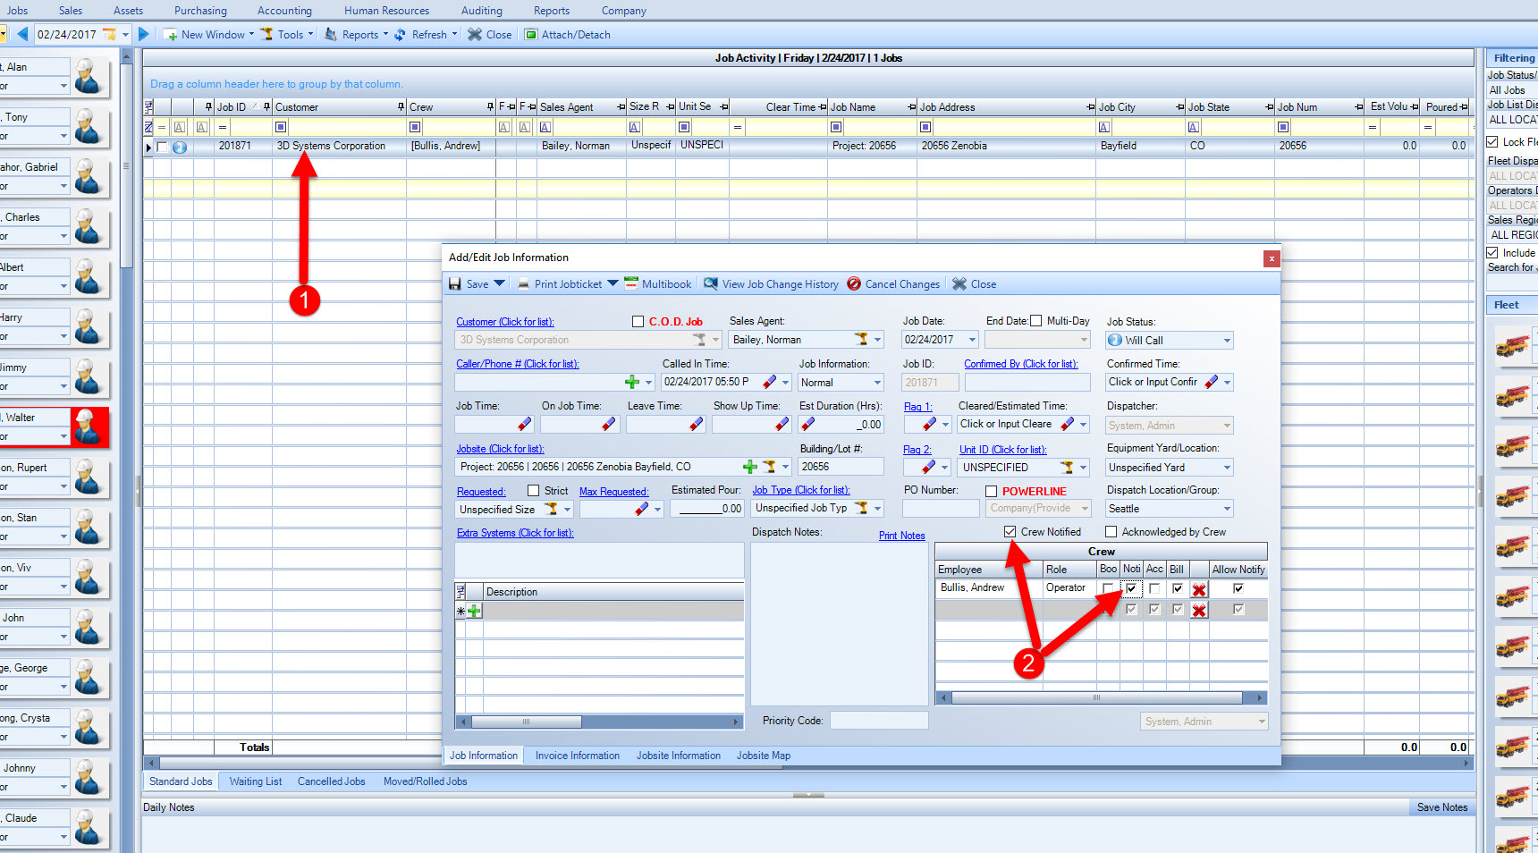
- Once the job is scheduled, check the “Noti” check box. Ensure that the Crew Notified box is checked as well, then Save&Close the job and the operator will receive his job.

Chapter Two

Book Job To Allow For Status Updates
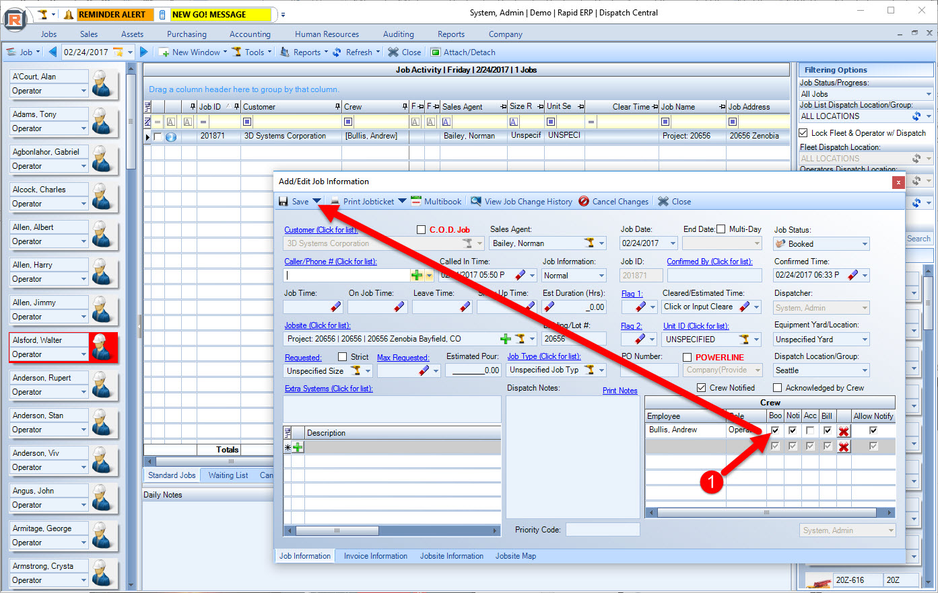
- Now that the job is scheduled, you must ensure the job is booked before the operator can begin updating his Job Statuses. (Note: This is because you may not want the operator to choose In Route, when really his job is not for another two hours, this feature gives you, “the dispatcher” more control).

Chapter Three

Accepting Job Ticket On Invoice
- Once the job is completed, you can double click on the job to open it up.
- Next navigate to the Invoice Information tab.
- Check to make sure all job information entered by the operator is correct.
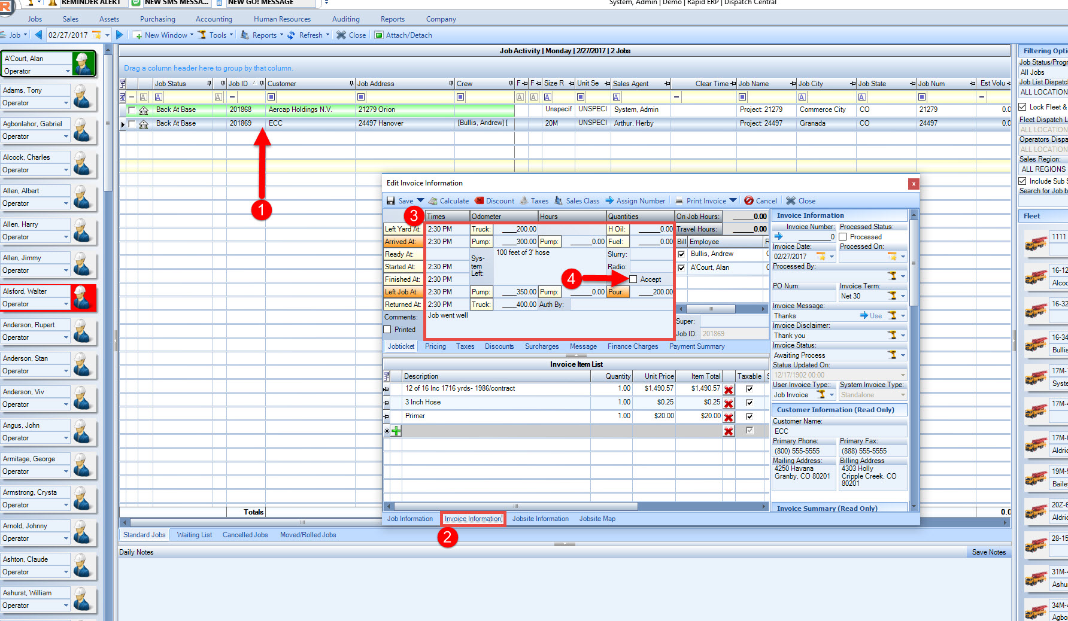
- Once all job information is accurate, you can accept the job which will move the job from Ticketing to Completed on the operators tablet. As always, save and close.

Chapter Four

Printing Filled/Signed Job Ticket
- To print out the filled/signed copy of the jobticket simply open up the job.
- Next, select the dropdown arrow and select “Print Filled Jobticket”. This jobticket will have all the information the operator input as well as the signature taken by the contractor/super.
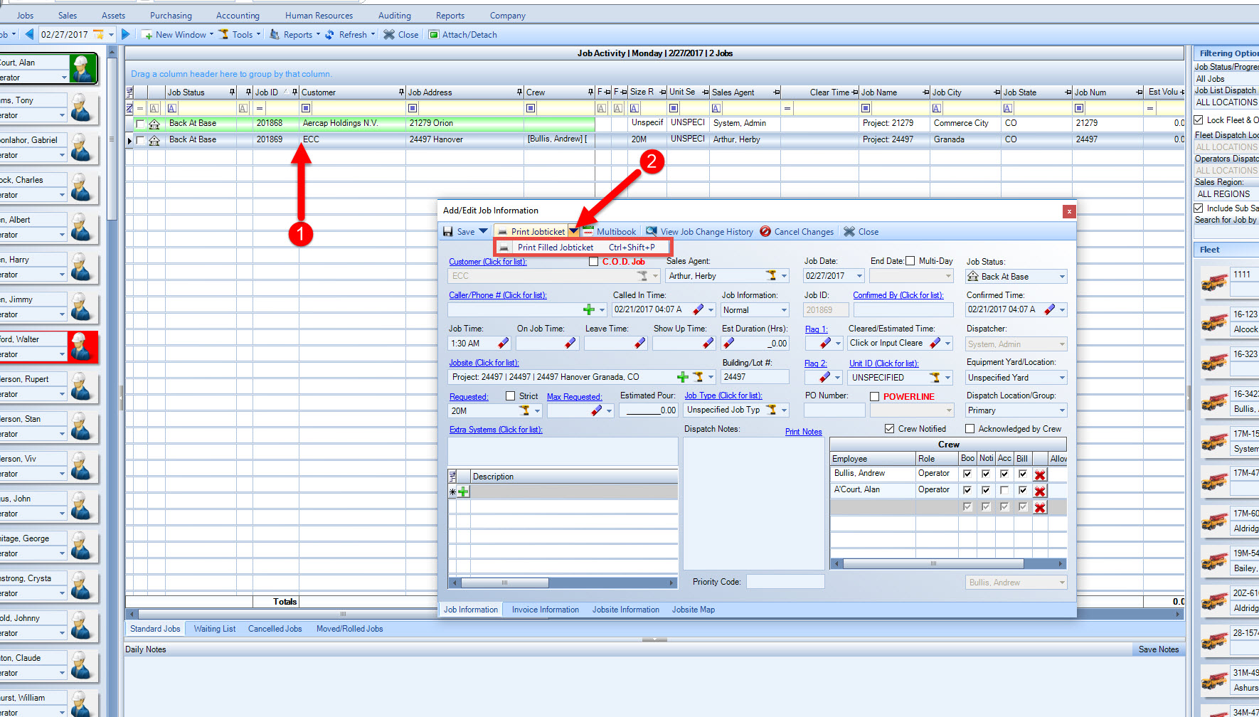

Chapter Five

Viewing Jobsite Images
- To view images of the jobsite taken by the operator, simply open up a job.
- Next, select the Jobsite Information tab.
- Select Resource Gallery.
- From here you will be able to see all images taken by the operator. Select an image to open it up.
- You can also upload your own images by selecting the Upload button.
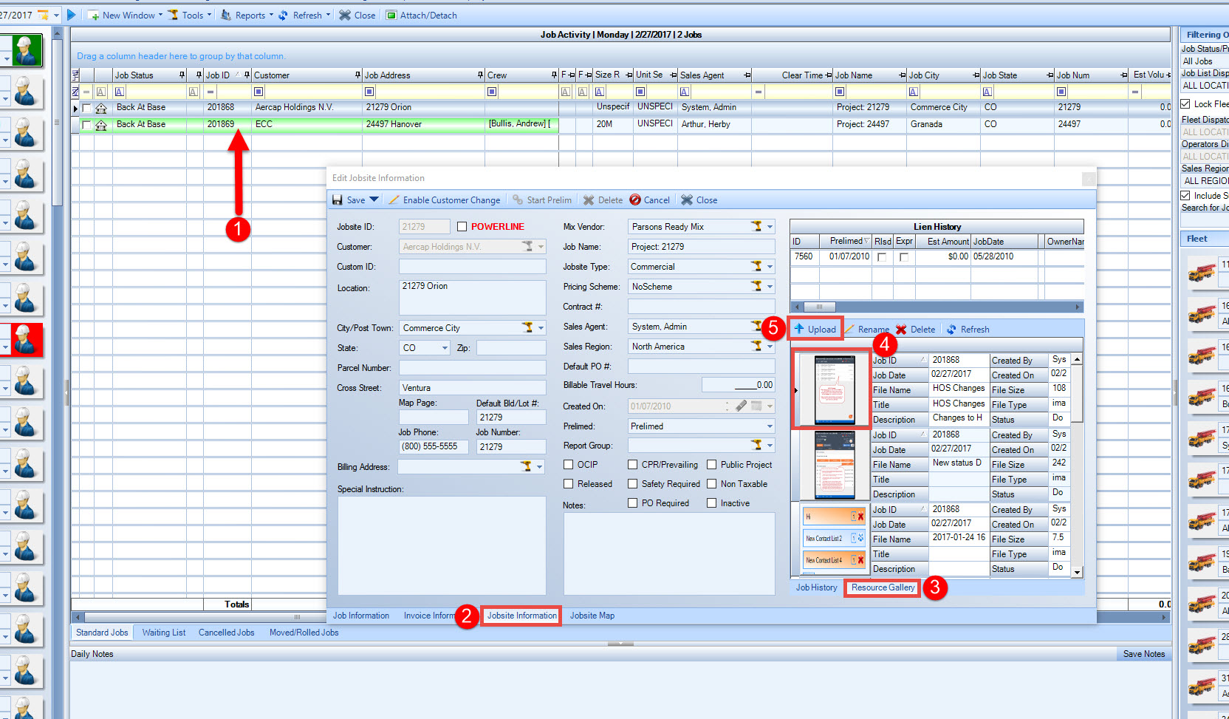

Chapter Six

Messaging To Tablet
- To send messages to the operators tablet simply select Company then Go! Messaging.
- Select Send New and choose the operator whom you wish to message. You can select any contact information including an email, phone number etc. As long as the name is shown in the grid.
- Next, enter the message that you would like to send.
- You can select message priorites which have different effects. If you send a normal message, the button on his tablet will light up green. A high priority message will light up as yellow. An urgent message will make all buttons flash different colors and a siren sound will play from the tablet.
- You can also send Canned Responses, this mean you can specify button option replies for the operator. When they view the message, they will only be able to reply with the buttons you specified for them.
- Lastly, select Send to send out the message.
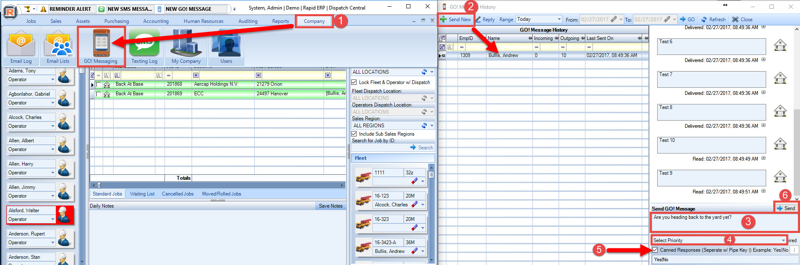

Chapter Seven

Verifying Jobsite Locations
- To verify the location of the jobsite for the operator simply open the job.
- Select Jobsite Map.
- The pin is the Longitude/Latitude of the jobsite address. If this is incorrect, you can drag and drop the pin to the correct location.
- Once the pin is in the correct spot, you can Verify the location for future use.
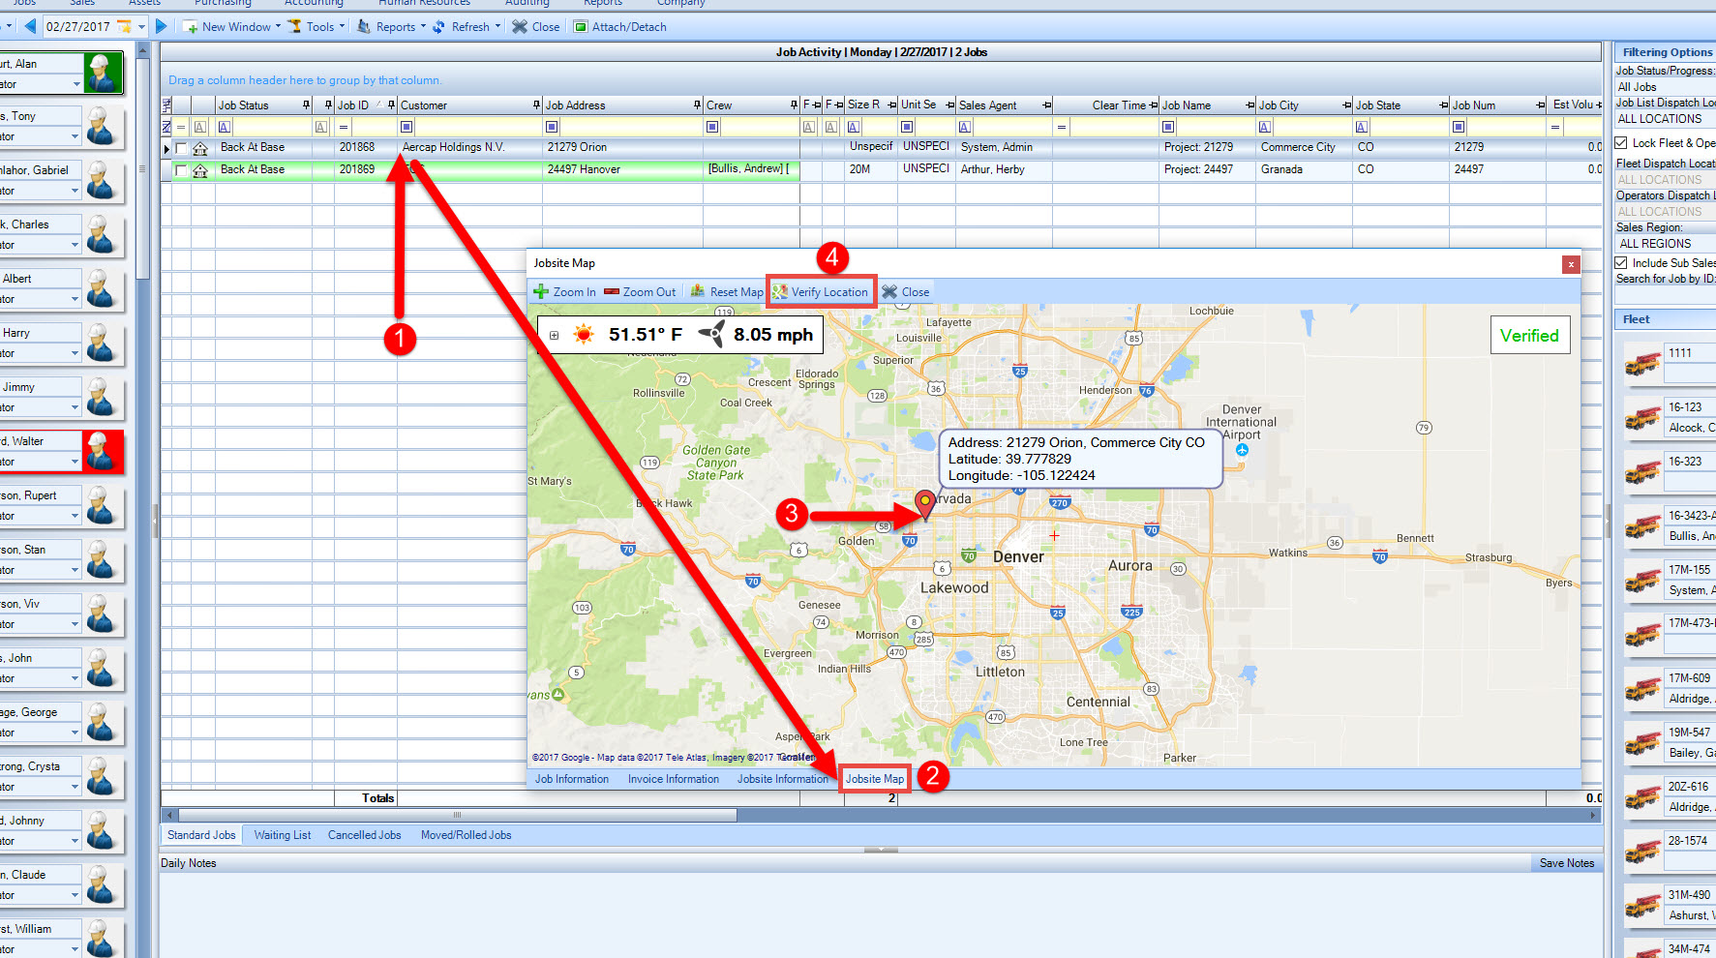

Chapter Eight

Viewing Go Tab Trip Map Logs
- To view the Go Tab trip map logs, select the Tools button from the toolbar.
- Next, select GO! Tab Units & Trip Logs.
- Then double click on the unit you wish to view the trip logs for.
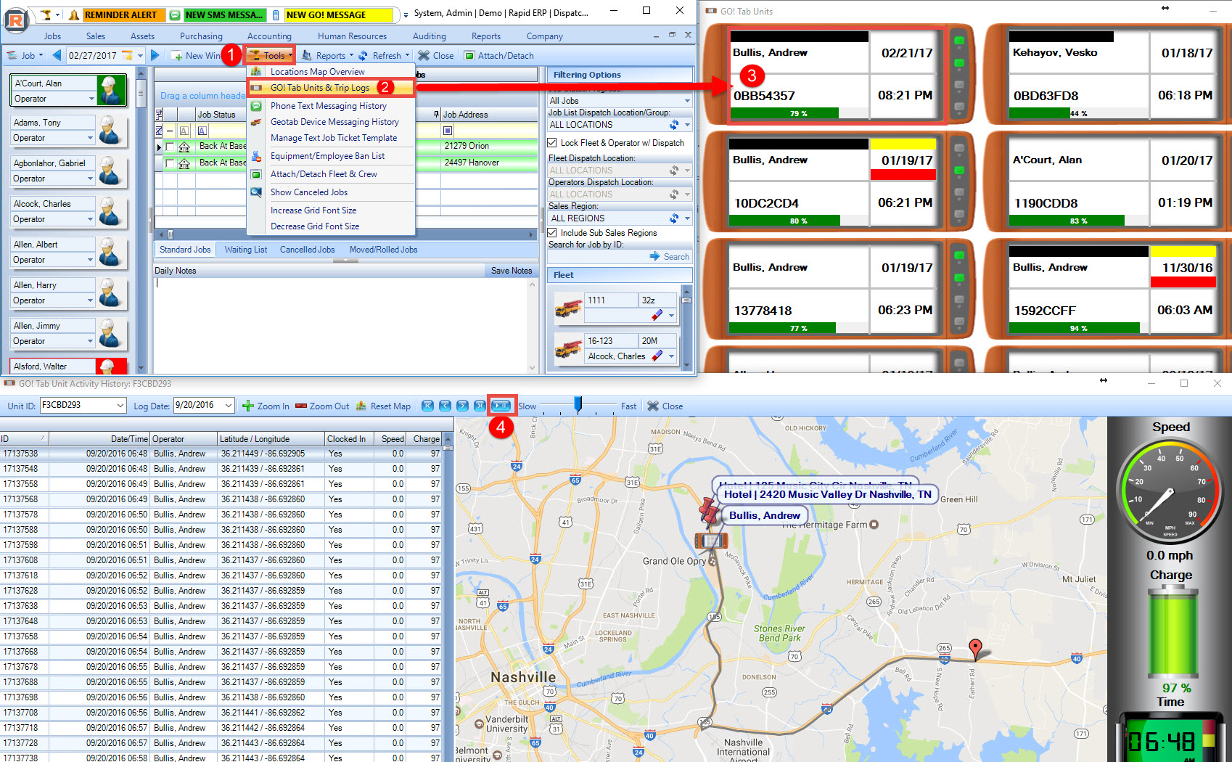
- From here, you will be able to select the play button to see a play by play of where the Go Tab went.

Chapter Nine

Viewing Tablets On Jobsite Map
- To view all tablets, select the Tools button from the toolbar, then select Locations Map Overview.
- Next, make sure the Hide GO! Tab Units check box is unchecked.
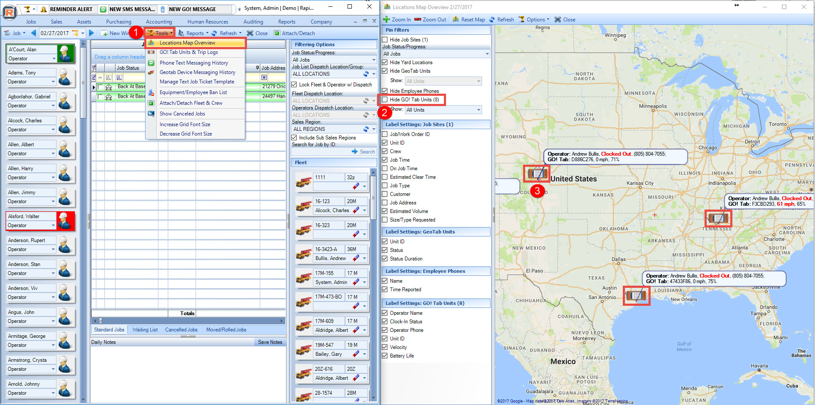
- You should see all devices that are currently clocked in, you can also double click on a device to view the trip map logs.

