4393 Pierson St p. 303-500-3050 Support@rapidappsinc.com
Wheat Ridge CO 80033 www.rapidappsinc.com

Rapid Applications Group, LLC.
  - ROTG Manual

Rapid ERP Systems

Author: Andrew Bullis
Edit Version: 1.0
Version Date: 8/15/2015

Chapters
Chapter 1: Tablet Button Functionality
Chapter 2: Opening ROTG/Logging In
Chapter 3: Receiving Job Information
Chapter 4: Job Statuses
Chapter 5: Time Entry
Chapter 6: Ticket Entry
Chapter 7: Routing Back to the Yard
Chapter 8: Viewing/Messaging
Chapter 9: Tracking DOT HOS
Chapter 10: Clocking in and Out

Introduction
This manual will cover all aspects required to use Rapid On The Go for all operators alike. The goal of learning this manual should be to become an efficient and effective operator by using ROTG and its features to assist you in your daily routine. In the manual we will cover all of the main components, features, and perks of ROTG so that you can become the best operator possible. We will show you how to optimize your tablet experience in a seamless process. Some of the key points we will covering in this manual are as follows.
- Receiving your electronic job.
- Updating job statuses for the office.
- Filling out your e-ticket.
- Sending texts and emails from Rapid On The Go.
- Tracking your DOT HOS.
- Routing to the job and verifying jobsite geo locations.
- Clocking in and out for time cards.
- Taking and saving job site images for dispatch.

Chapter One

Tablet Button Functionality
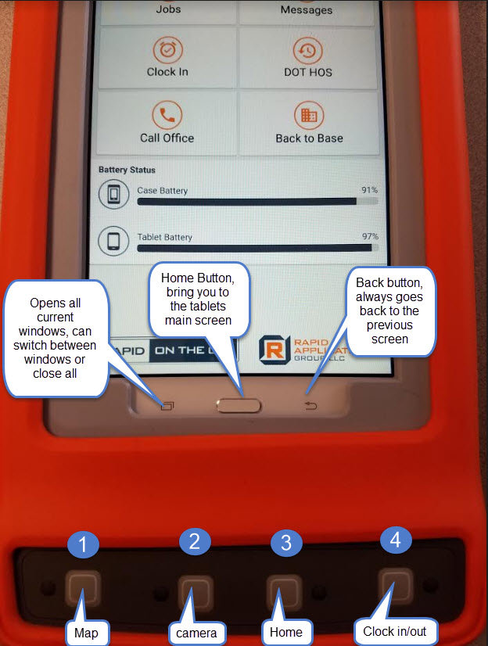
- Press once, opens Google Maps and shows your current location. Hold for 3 seconds, opens google maps and route to next jobsite. If there are no pending jobs, it will route back to base/yard.
- Press once, opens camera, press again to take picture. Select save image and it will return to home screen.
- Press once, will return to ROTG home. Navigation buttons, if button is red = battery low. If green, you have a new standard message, click to open message. If yellow = high priority message. If all buttons are flashing colors = urgent message, click any button to open.
- Clock in/out button, hold down for 3 seconds, give you option to clock in or out depending on clocked status. If pressed once, will show timestamp of last status.

Chapter Two

Opening ROTG/Logging In
- Select the Rapid On The GO! application to open.
- You must obtain your login information from your office staff, login information includes the Username, Password, and ClientID.
- Username.
- Password.
- ClientID.
- Remember Me, to remember all information entered above.
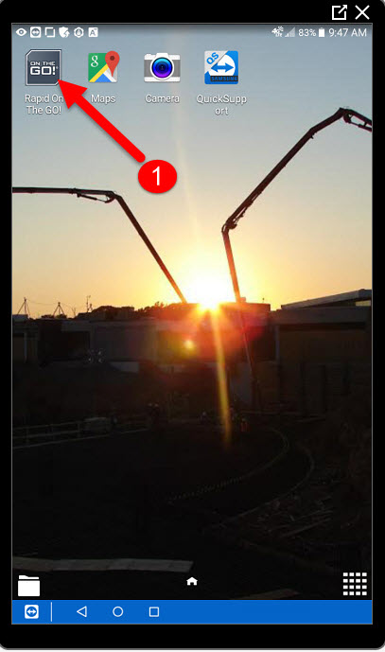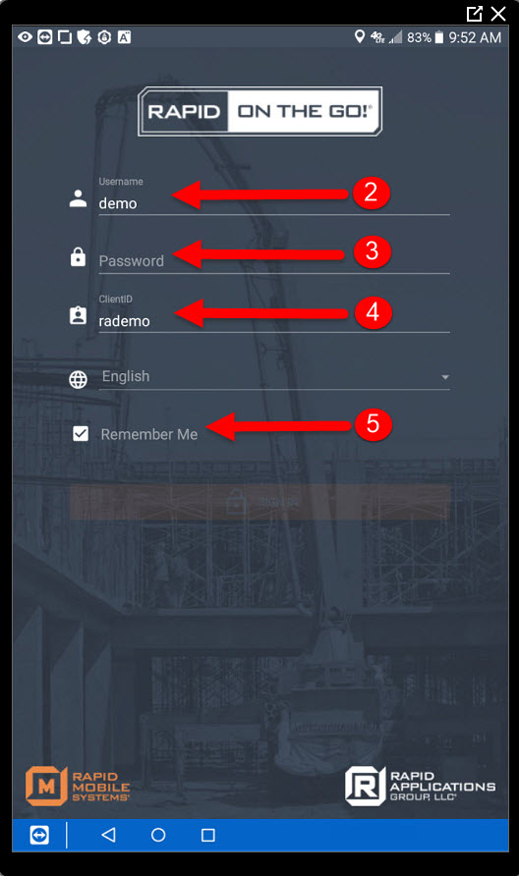

Chapter Three

Receiving Job Information
- Once logged in, select Jobs.
- By default you will be under Pending Jobs.
- You will see your jobs for the day listed below. Select a job to open it up.
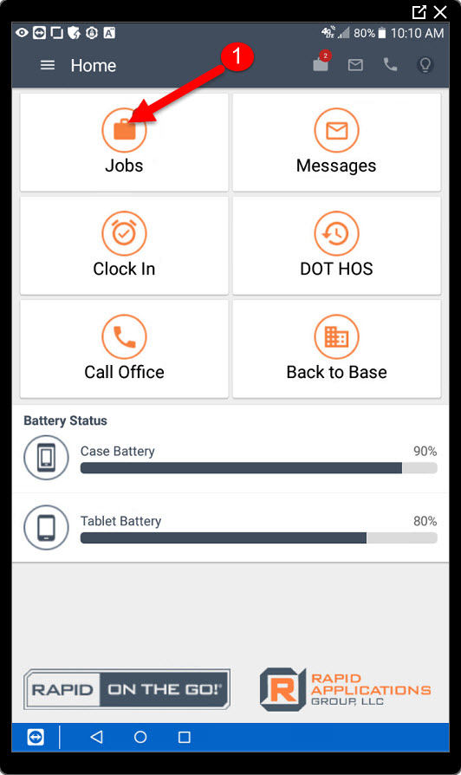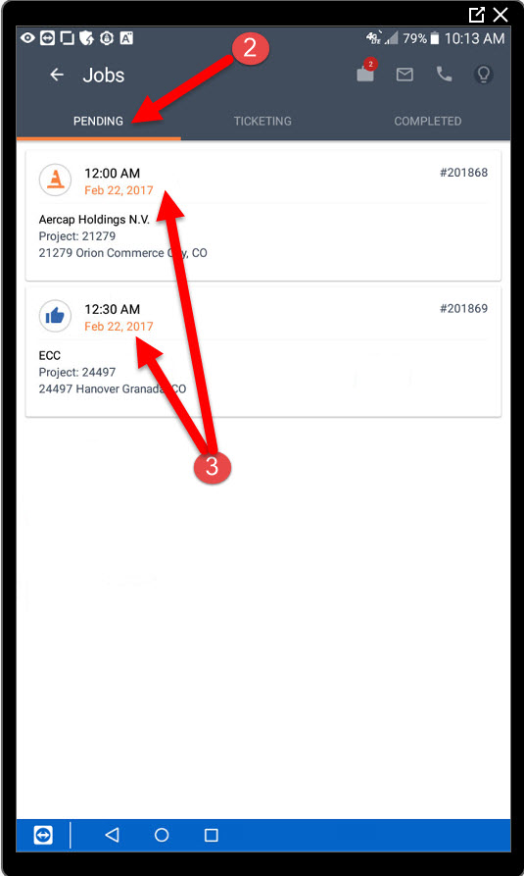

Receiving Job Information Continued
- Encased in red is all your job information.
- Select the icon to verify your current location when you are on the job for future use. (Note: This DOES NOT verify the address you see on the left, it verifies your current location.
- Select the route to the jobsite using Google Maps.
- Select to send a message to the office.
- Select to take a picture and attach image to the job.
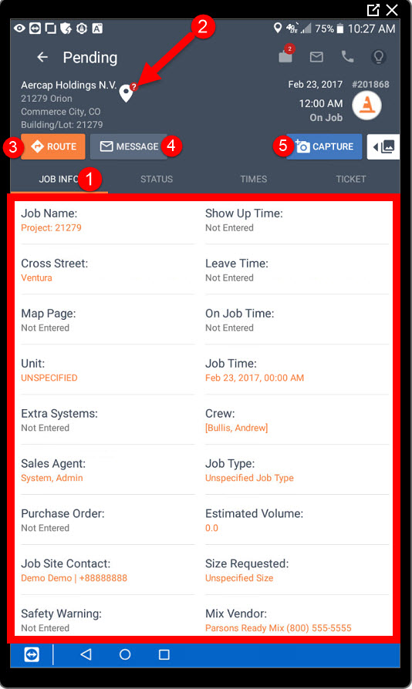

Chapter Four

Job Statuses
- Once you are ready to leave the yard, select the “Status” tab.
- You must first acknowledge the job before you can begin updating your job statuses.
- Once the job is acknowledged, you can select your first status, In Route. Continue through the rest of the status buttons based on your activity.
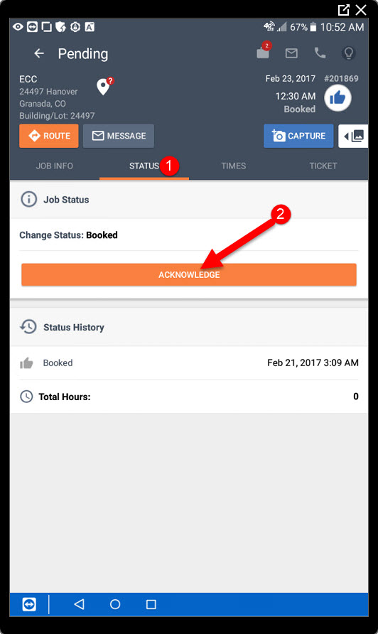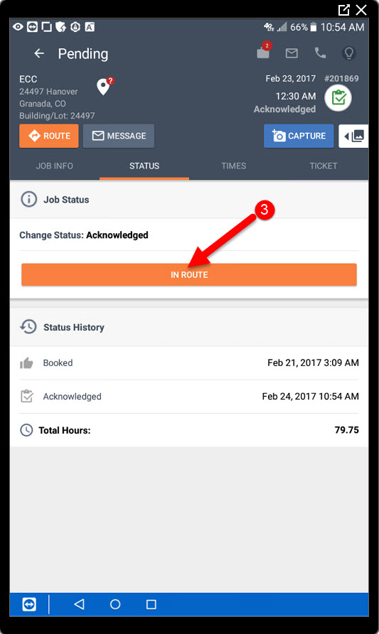

Chapter Five

Time Entry
- Once you have completed the job and the status is set to back at base, notice the job has now moved from the Pending tab to the Ticketing tab.
- Here is your job in the ticketing tab.
- Next, select the Times tab inside of the job.
- Notice some times fields are filled out automatically, the In Route status time stamped the Left Yard Time
- The On Job status time stamped the Arrived At time.
- The Returning status time stamped the Left Job time.
- The Back At Base status time stamped the Returned time.
- You can also get the pre job signature here.
- As well as a post job signature.
- From the post job signature you can also send an email copy of the jobticket by entering an email address.

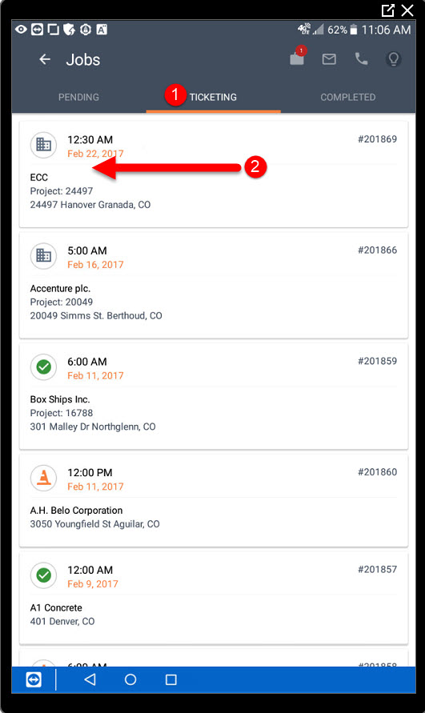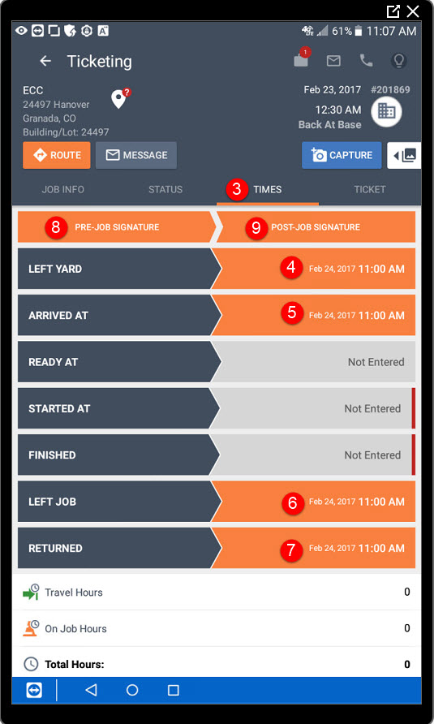

Chapter Six

Ticket Entry
- Next, you will want to fill in your ticket information by selecting the Ticket tab. Encased in red is all of your ticket information.
- Notice the save option is not available yet. This is because you have required information that is not currently entered.
- You must tab back over to the Times screen and fill in any fields marked with a red indicator.
- Finish by entering your required Started At time.
- Finish by entering your required Finished time.
- Now you be able to go back to Step 1, the ticket to save the information. Once saved the jobticket email will be sent to the receiver
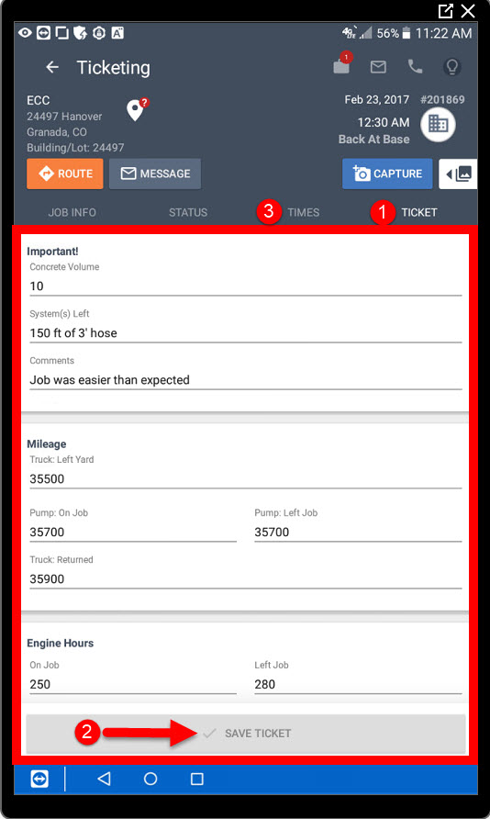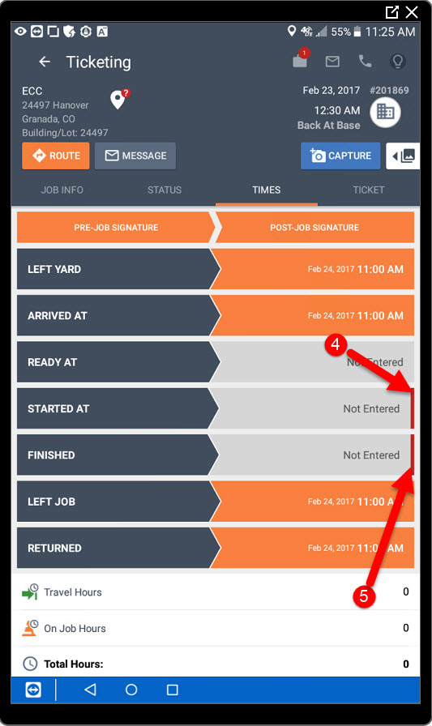

Chapter Seven

Routing Back To The Yard
- Next, you will want to route back to the yard, unless you have another pending job, revert back to Chapter 3 and continue the process again. Select button number 3 to bring you back to the ROTG home screen. See Chapter 1 for reference.
- Select the Back to Base button to choose which yard you would like to route to.
- Then select a yard location that you would like to route to, Google maps will open with the address of the yard.

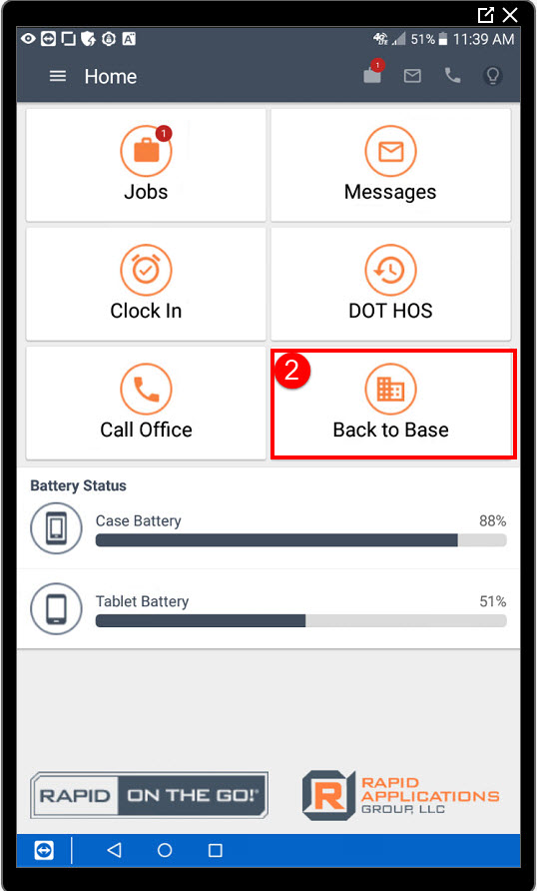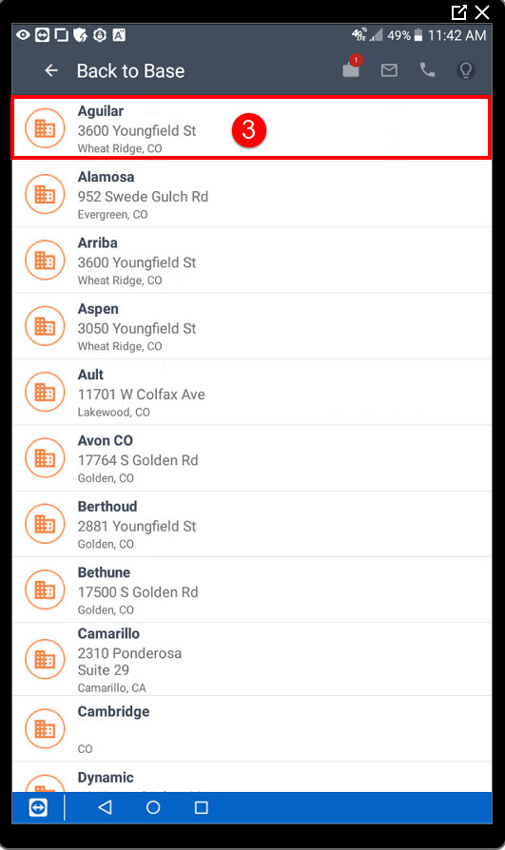

Chapter Eight

Messaging The Office
- From the home screen, select Messages.
- From here you will see any unread messages. Here is your message, select to open.
- You can also filter based on read message, or unread messages and a few other options.
- As well as the most recent, oldest, or high priority messages.
- To send a new message to the office, select the icon then type in the message and press Send Message.
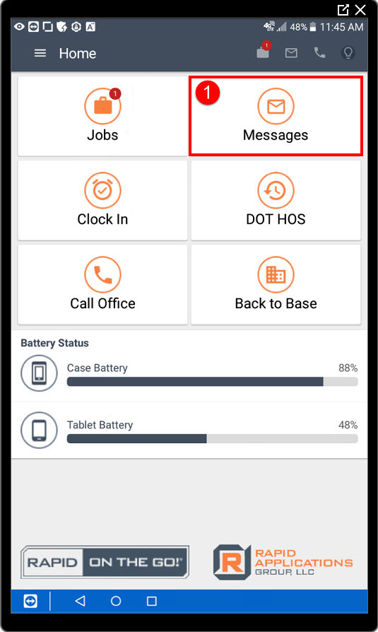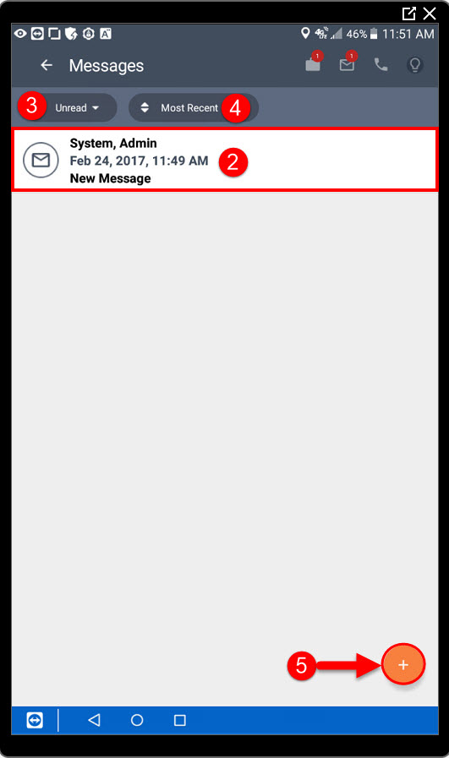

Chapter Nine

Tracking DOT HOS
- From the home screen, select DOT HOS
- Next select the type of service log you would like to fill out.
- Select the icon to log a new days HOS.
- Then enter the date, total miles driving, and the Unit number. (See next page for image)
- Next, select the View/Edit Driving Log Form to fill in the corresponding times. (See next page for image)
- To enter times, simply drag your finger across the correct row. (See next page for image)
- Here you can see your entire log for the day. (See next page for image)
- Next, select the back button to finish with the signature and select the button.(See next page for image)
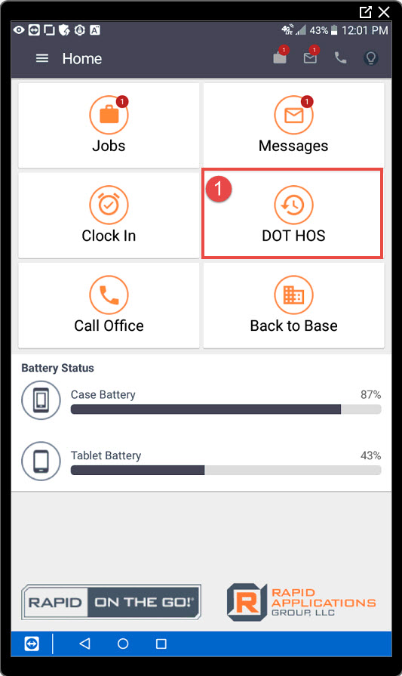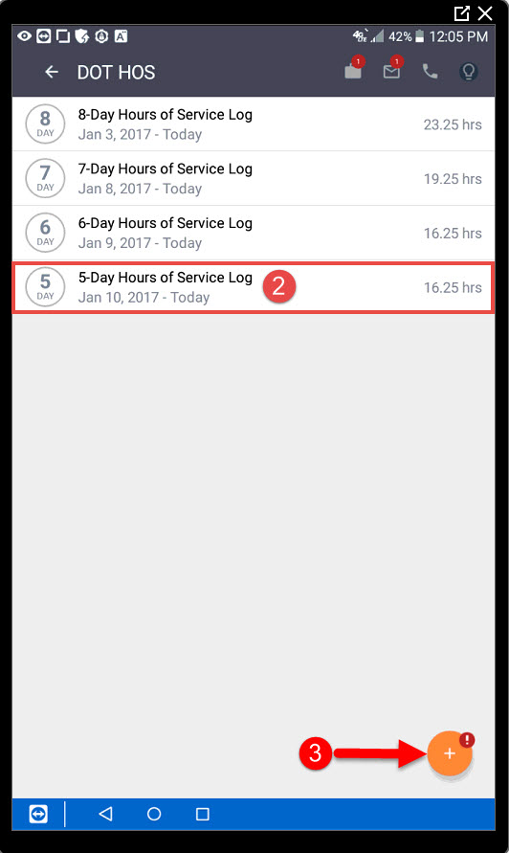

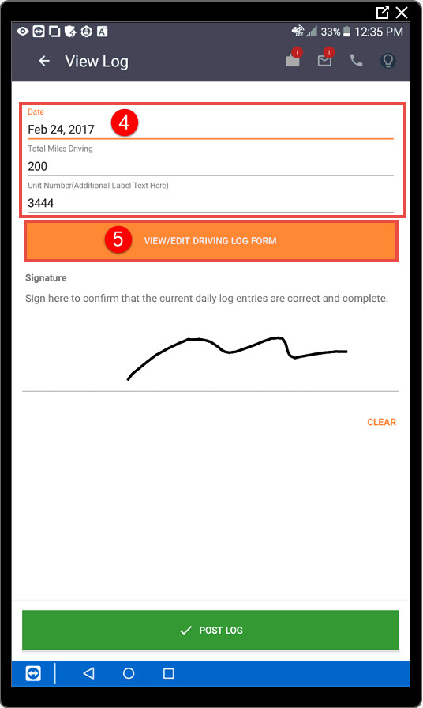

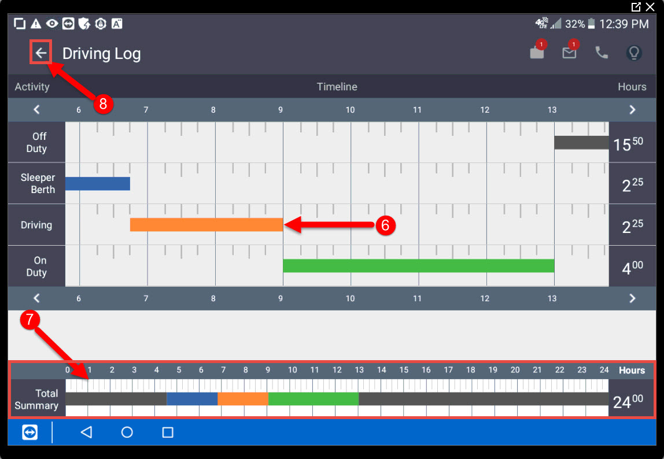

Chapter Ten

Clocking In/Out
- From the home screen, select Clock In.
- Notice the icon turns green, if you click the icon it will notify you what time you clocked in. To clock out, repeat step 1.
- You may also use button number 4 to clock in and out, see Chapter 1 for more information.
